AI ASSISTED CODING
ASSIGNMENT-3
B.Sri Laxmi Gayathri
2303a52033
Batch:38
Lab 3: Prompt Engineering – Improving Prompts and Context Management
Task Description-1
Progressive Prompting for Calculator Design: Ask the AI to design a simple calculator program by initially providing only the function name. Gradually enhance the prompt by adding comments and usage examples.
Expected Output-1
Comparison showing improvement in AI-generated calculator logic and structure.
Prompt:
Generate a calculator program when only the function name is provided.
Comments:
1. This program demonstrates progressive prompting, where improving the prompt results in better structured and more reliable calculator code.
2. The calculator function performs basic arithmetic operations and includes error handling for division by zero and invalid operators.
Explanation:
This task explains how improving a prompt step by step helps the AI generate better code. When the prompt is simple, the code is basic. As more details, comments, and examples are added, the code becomes clearer, safer, and easier to understand. This shows that clear prompts lead to better programming results using AI tools.
Code:
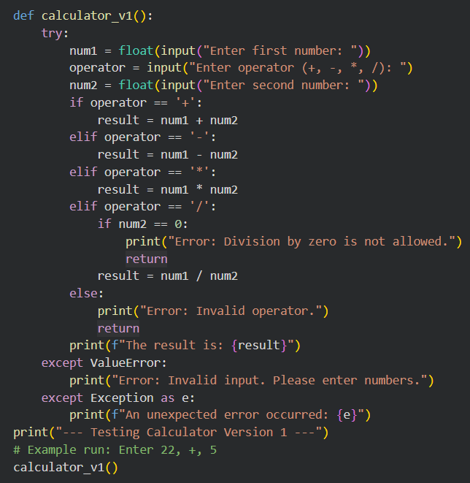
Output:
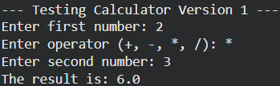
Task Description-2
• Refining Prompts for Sorting Logic: Start with a vague prompt for sorting student marks, then refine it to clearly specify sorting order and constraints.
Expected Output-2
• AI-generated sorting function evolves from ambiguous logic to an accurate and efficient implementation.
Prompt:
Write a Python function to sort student marks in ascending order. Show the original list and the sorted list.
Comments:
1. This task shows how refining a vague prompt helps the AI generate a correct and well-defined sorting function.
2. Clear instructions about sorting order and constraints improve the accuracy and efficiency of the code.
Explanation:
This task shows how improving a prompt step by step helps the AI generate better sorting logic. When the prompt is vague, the sorting code is basic and unclear. As the prompt specifies the sorting order and input rules, the code becomes more accurate and efficient. Adding clear constraints helps avoid errors and improves correctness. This proves that clear prompts lead to better AI-generated programs.
Code & Output :
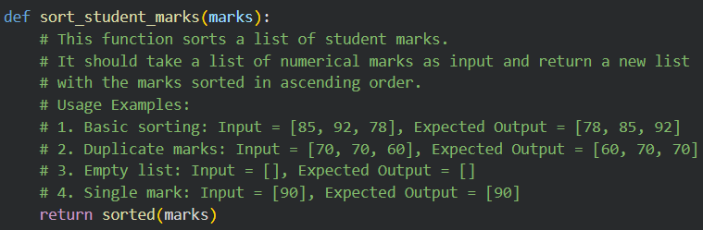
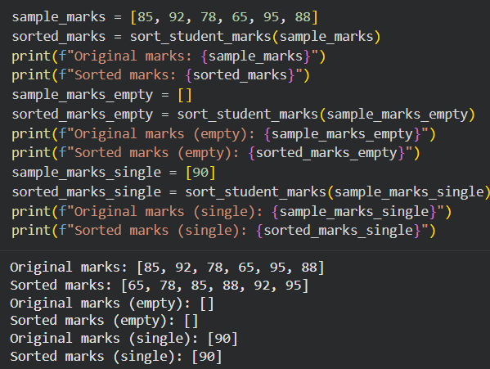
Task Description-3
• Few-Shot Prompting for Prime Number Validation: Provide multiple input output examples for a function that checks whether a number is prime. Observe how few-shot prompting improves correctness.
Expected Output-3
• Improved prime-checking function with better edge-case handling.
Prompt:
Write a Python function to check whether a number is prime.
Comments:
1.Few-shot prompting helps the AI understand prime number rules through examples, improving accuracy.
2.Providing edge-case examples leads to better handling of numbers like 0 and 1.
Explanation:
This task explains how few-shot prompting improves prime number validation by giving example inputs and outputs. When examples are provided, the AI clearly understands which numbers are prime and which are not. This helps the function handle edge cases like 0, 1, and even numbers correctly. As a result, the generated code becomes more accurate and reliable.
Code & Output :
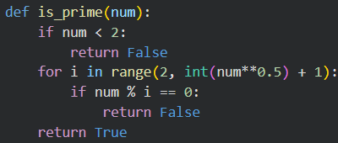
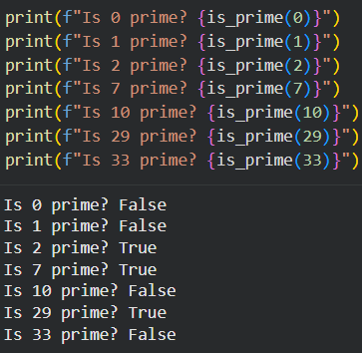
Task Description-4
Prompt-Guided UI Design for Student Grading System: Create a user interface for a student grading system that calculates total marks, percentage, and grade based on user input.
Expected Output-4
Well-structured UI code with accurate calculations and clear output display.
Prompt:
Design a UI for a student grading system that calculates total marks and percentage. Display the results on the screen.
Comments:
1.Prompt-guided instructions help the AI design a clear and well-structured user interface.
2.Clear requirements ensure accurate calculations and easy-to-understand output display.
Explanation:
This task explains how clear prompts help in designing a proper user interface using AI. When the prompt clearly mentions inputs, calculations, and output display, the AI creates a structured and user-friendly grading system. The UI correctly calculates total marks and percentage and assigns grades based on the result. Clear prompts also help in displaying results neatly. This shows that prompt guidance improves UI design quality.
Code & Output:
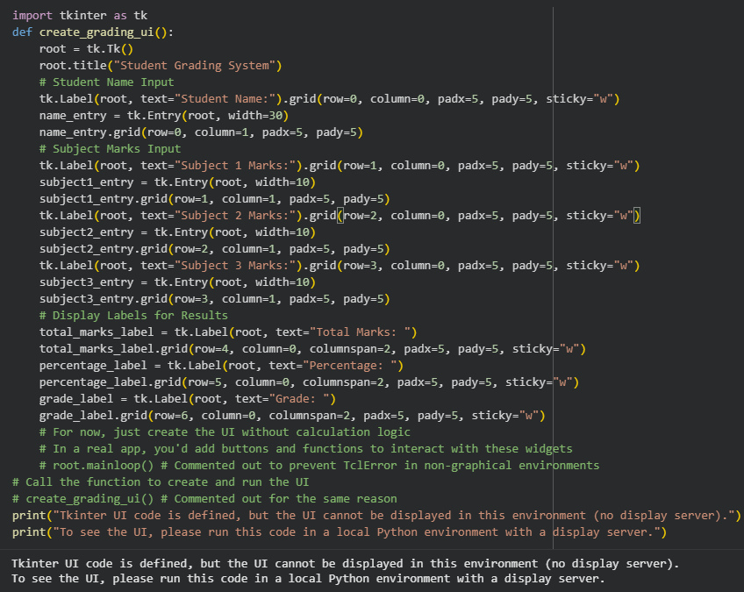
Task Description-5
Analyzing Prompt Specificity in Unit Conversion Functions: Improving a Unit Conversion Function (Kilometers to Miles and Miles to Kilometers) Using Clear Instructions.
Expected Output-5
Analysis of code quality and accuracy differences across multiple prompt variations.
Prompt:
Write a Python function that converts kilometers to miles and miles to kilometers. Show clear output for both conversions.
Comments:
1.Clear and specific prompts help the AI generate accurate and reliable unit conversion logic.
2.Adding conversion direction and input rules improves code correctness and readability.
Explanation:
This task explains how prompt specificity affects the quality of AI-generated unit conversion functions. When the prompt is vague, the conversion logic may be incomplete or inaccurate. By clearly specifying conversion types and input rules, the AI produces correct and reliable code. Clear instructions also help in handling invalid inputs properly. This shows that detailed prompts lead to better and more accurate programs.
Code:
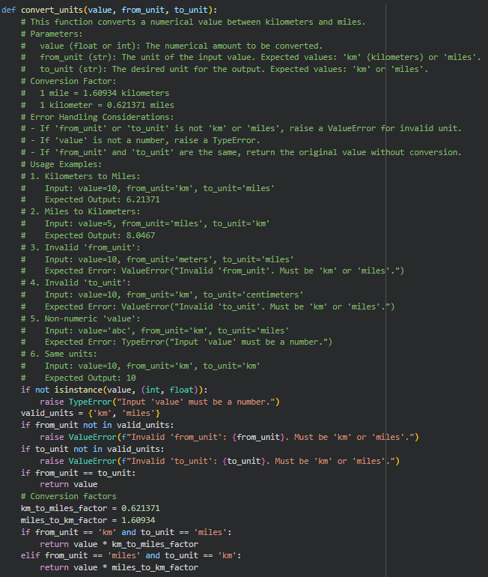
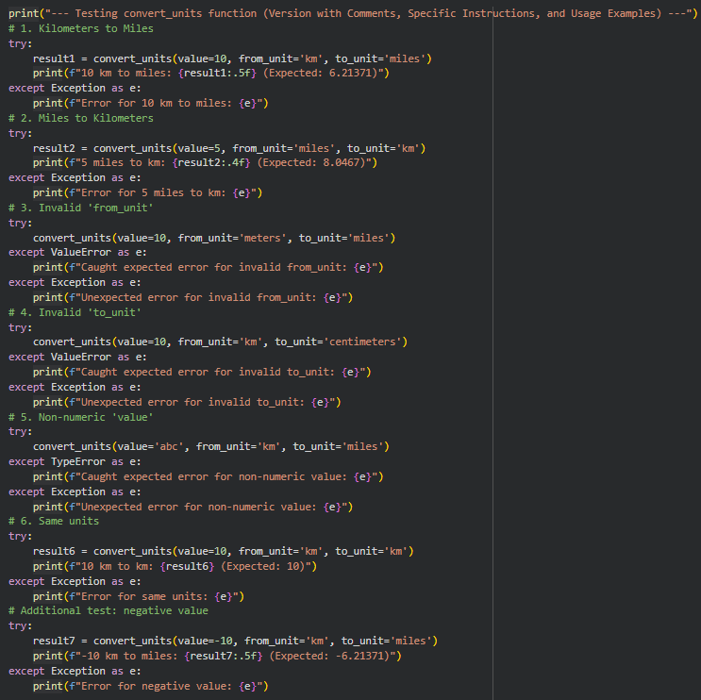
Output:
